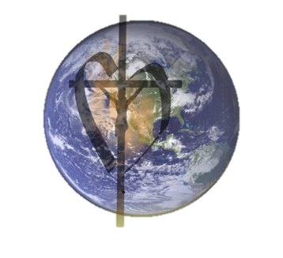
Laudato Si’ Action Platform Commitment
Spiritual Dialogue

This Spiritual Dialogue uses commitments taken from the “Laudato Si Action Platform Commitment” and reflections taken from “Laudato Si: Daily Reflections by The Daughters of Charity –Kenya” (2017).

There are four Commitment statements, each with a reflection and a question for dialogue.

Commitment: We commit to growing in our understanding of Integral Ecology and “how inseparable the bond is between concern for nature, justice for the poor,
commitment to society, and interior peace.” (Pope Francis)

Reflection: “God has given us a beautiful world of mountains and lakes, waterfalls and other incredible sights of breathtaking sceneries day and night. But nowadays in some parts of the world instead of northern lights and aurora borealis that people enjoy in the middle of darkness, we see bombs or missiles light up the sky.”

Sr. Caridad Tatayon, DC. “God’s Creation, Man’s Destruction”

Dialogue: How do I understand the connection between concern for nature, justice for the poor, commitment to society, and interior peace?

Commitment:
As Daughters of Charity, we commit to joining the Global Church and our Global Community, to grow daily in our choices so that we honor and respect the smallest creatures and all our sisters and brothers that we may all share in the glory of God’s creation.

Reflection: “Each single thing affects the whole, each is needed and each is in a sense a part of me as I am a part of it. My love for creation is God’s love for his creation residing in my heart. I cannot harm creation because it would be like harming myself. I, together with every man woman and child on the planet have my part to play in the development and the survival of our common home. I take this responsibility with both hands and try to increase my level of care and its practical application.”

Sr. Susan Viney, DC. “Everything is Inter-connected –Laudato Si Chapter 4 & 5”

Dialogue: How do I see myself as part of the whole?

Commitment: We commit to deepening our Ecological Conversion, by broadening our education for ourselves and others on the current environmental crisis. We commit to taking concrete actions individually and as a community
to bring healing to Earth, to end the misuse of creation,
and to call on our nation’s leaders to bring about lasting environmental changes.

Reflection: “Some simple things I (we) can do to make a little difference are: have educational programs on how to protect our local environment and to form a group of students and adults in the area to decide on practical projects we will do to positively affect our community.”

Sr. Mary Shea, DC. “What Can I Do”

Dialogue: Is there a possibility of starting an educational program in my ministry? What is my local Community interested in learning more about? Is there an opportunity to discuss “practical projects” in my ministry or local Community?

Commitment: We recognize there are ecological limits to the use of Earth’s resources. We commit to live simply and to use the gifts of creation with awareness, care, and gratitude.

Reflection: “Simplicity is a Vincentian characteristic; we are called to be simple and to appreciate all of God’s creation. Let us pray for a deepening of our capacity to be happy with little.”

Sr. Catherine Madigan, DC. “Living Laudato Si”

Dialogue: What blessings of God’s creation have I savored today?

